Social Studies 6 Name _______________________

Ancient China Date _______________________

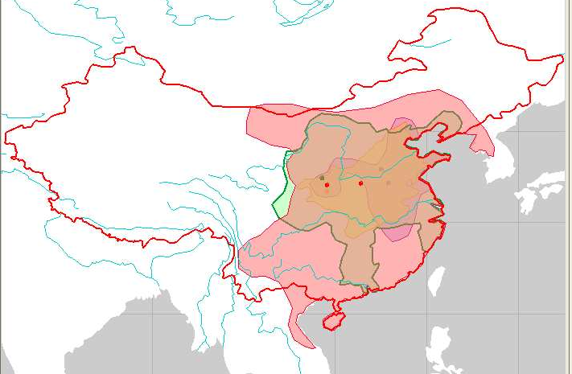
Geography of China

China is the third largest country in the world with an area of almost 3.7 million square miles and a population of about 1.2 billion people.₁ Ancient China was not nearly this size, but it was a large and powerful nation. The map to the right shows modern China outlined in red, with Ancient China represented by the shaded areas. The Chinese often refer to the shaded area as “Inner China” and the areas to the north and west as “Outer China₂”. We will focus on the ancient area known as Inner China.

The Geography of Inner China – a Land of Rivers.
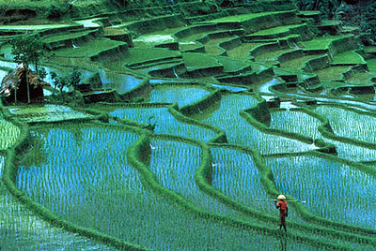
Inner China is a land of rolling hills, river valleys, and plains. Rivers flow through this area from the west. They provide water for irrigation, and floods from these rivers enrich the soil. China’s rivers flooded each spring, bringing fresh, fertile topsoil to the land. China’s first farming villages developed along its rivers. Inner China has two main regions. The northern region is the North China Plain. It is made of soil deposits from the Huang He River, which flows to the Yellow Sea. The Chinese people call the Huang He “China’s Sorrow” because its floods could be very destructive. Early Chinese people built dikes to help control flooding₃. Northern China has only a brief summer monsoon. There is not much rain at other times of year and the people depend on rivers to survive. The southern region is the Chang Jiang River Basin. This region has a very different climate. The Chang Jiang Basins are warm and wet, with monsoons that bring heavy rains from March to September. Light rain falls here the rest of the year, making it better farmland than the drier and cooler North China Plain. Much of china’s rice crop is grown in this area. The Xi River flows through the southern part of Inner China to the South China Sea.

Bodies of Water
Along China’s eastern coast line are three important seas. To the far north is the Yellow Sea. It lies between China and the Korean Peninsula. Near 30°N and surrounding the island now known as Taiwan is the East China Sea. Finally, to the south, where the Xi River flows, the South China Sea lies between China and the Philippine Islands₄.
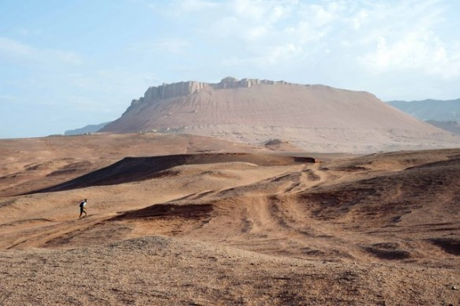
Landforms
China shares a border with India that was created by the natural barrier of the Himalaya Mountains, the tallest mountains in the world. China’s other important mountain range, the Altay Mountains are found much farther north, near the current nation of Mongolia. Also found along China’s northern border is the Gobi Desert. It marked the North West edge of ancient China, lying at approximately 40°N, 110°E.

A. Label the map: Read the article above and pay careful attention to the description of the places written in bold text and italics. Use the descriptions to help you decide where to write each name on the map on the back of this page. There are 10 places described - be sure to label all 10 of them on the map.

B. Five Themes Chart: There are four phrases that are underlined. Each one is followed by a number from one to four. Place the
number in the table to match that sentence or phrase to one of the Five Themes of Geography. One theme will not be used.

Theme | Sentence or phrase from article (use number)  C.Match a bold word from the  reading to its synonym.  __ c_ dikes a. damaging  __ d_ monsoons b. watering of crops  _ a_ destructive c. dams  __b__ irrigation d. storms  __e__ area e. size measurement  D. Write one complete sentence to summarize  the main idea of the second paragraph .  ______________________________________  ___They should probably mention rivers___  ____________________________________________________________________________  ______________________________________  ______________________________________
Location | 4
Place | 1
Movement | NOT USED
Region | 2
HEI | 3
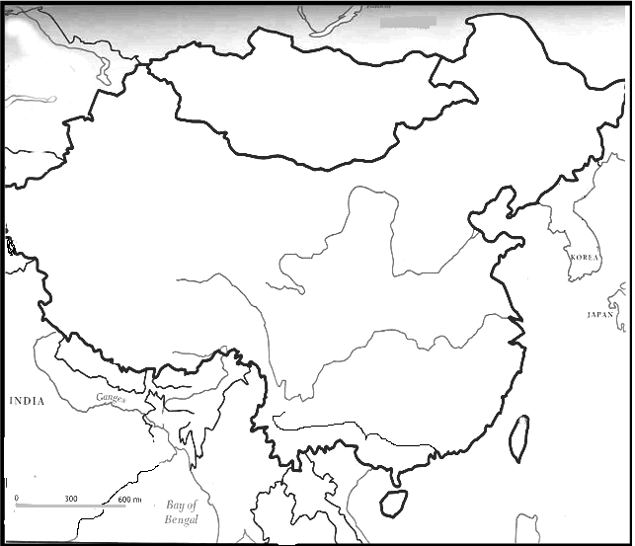

South China
Sea

East China
Sea

Yellow
Sea

Xi River

Chang Jiang River

Huang He River

North China
Plain

Gobi Desert

Himalaya Mts

Altay Mountains
A
PHILIPPINE
ISLANDS
(current)
90°E
100°E
110°E
120°E
TAIWAN
(current)
RUSSIA
(current)
N
MONGOLIA
(current)
40°N
20°N
30°N

E. Map questions:
1. On the map above, what does the dotted line represent? _limits of “Inner China”____
2. What is the distance from the mouth of the Xi River to the mouth of the Chang Jiang River? __850____miles

3. What is the distance from the Himalayas to the Altay Mountains? __1200__miles

4. Taiwan is (NE, SE, NW, SW) of Mongolia.

5. Russia is (NE, SE, NW, SW) of India

6. Which is the best estimate for the absolute location of the Xi River’s mouth? (21°N, 115°E) or (19°N, 115°E)

7. Estimate the absolute location of Japan - ___30°N, 130°E________________________

8. Estimate the absolute location of Point A - ___38°N, 96°E ______________________

9. Write a complete sentence to describe the relative location of the Philippine Islands - ___________________________

_____P. I. are south of Taiwan, or P. I. are south east of China, or any other descriptive sentence that does not
use latitude and longitude______

