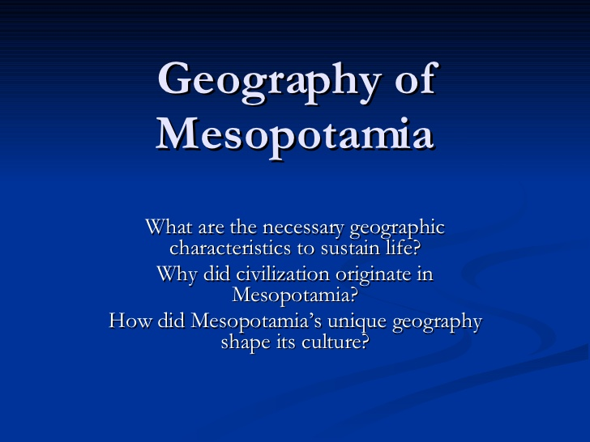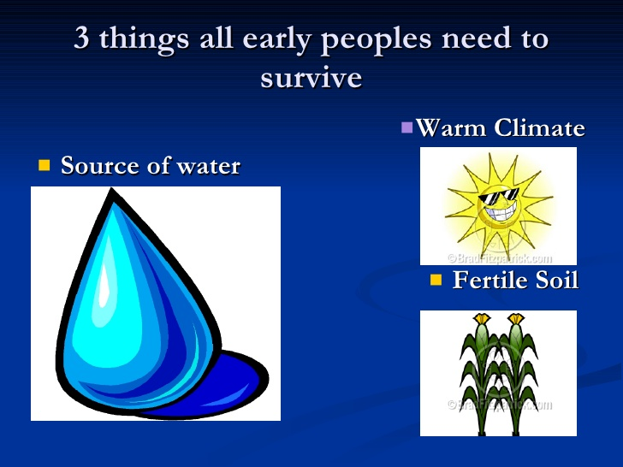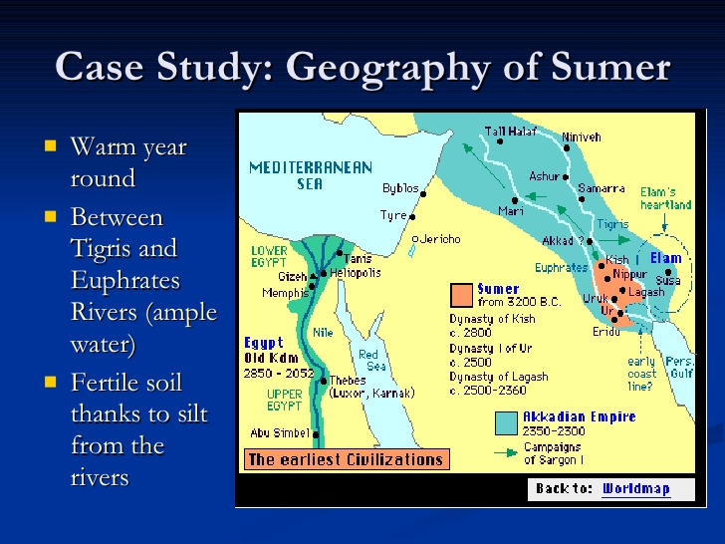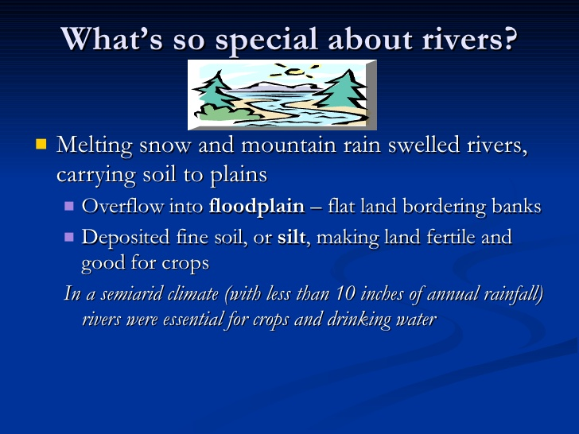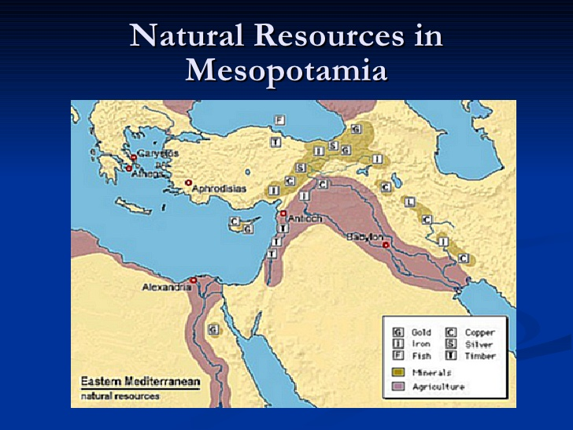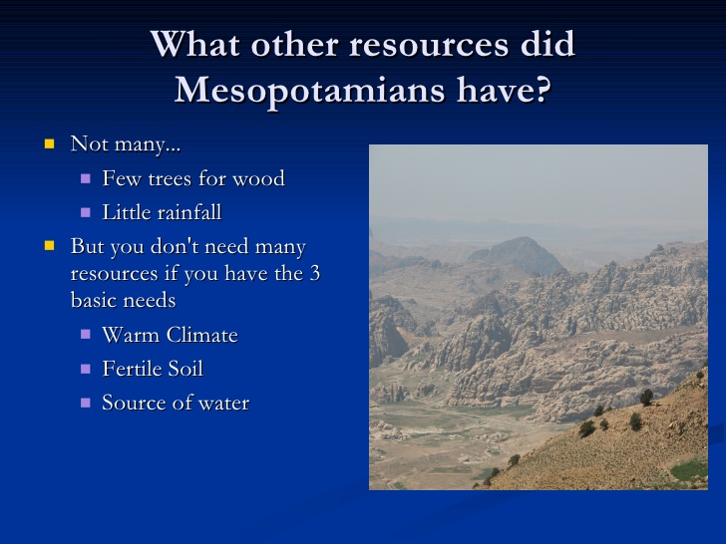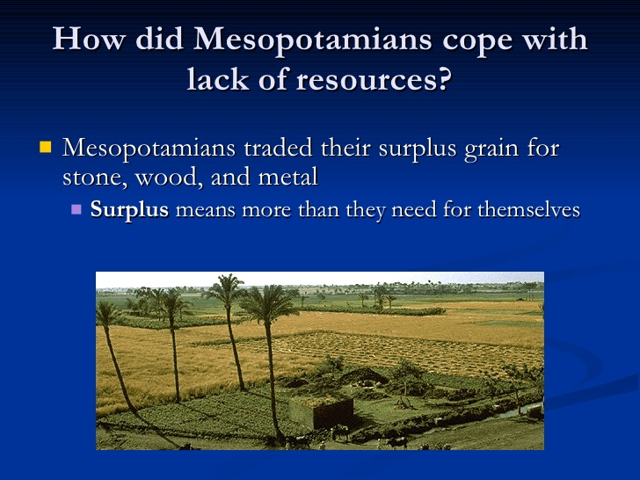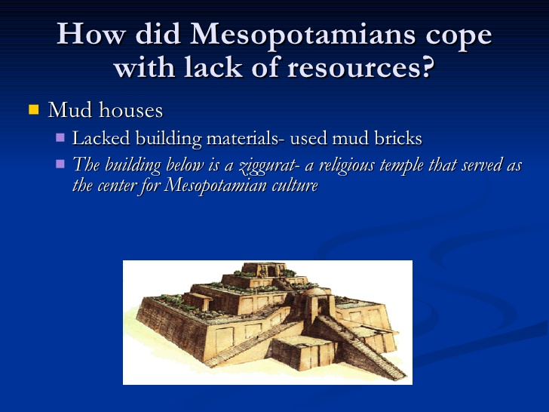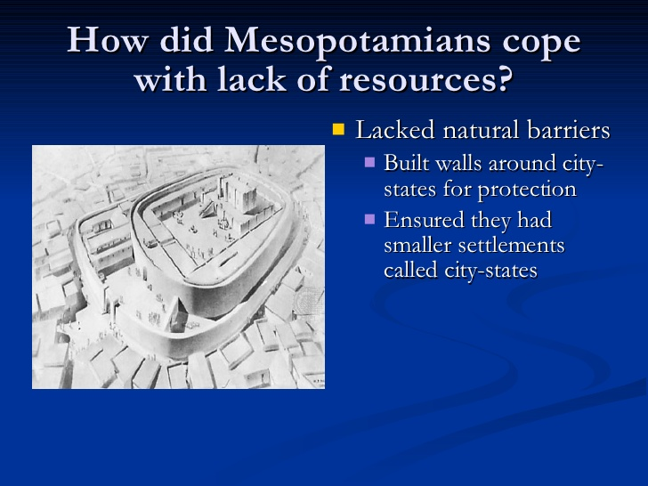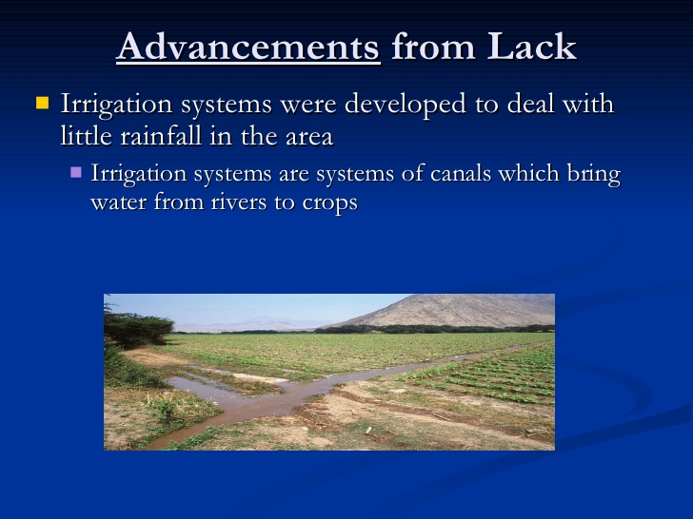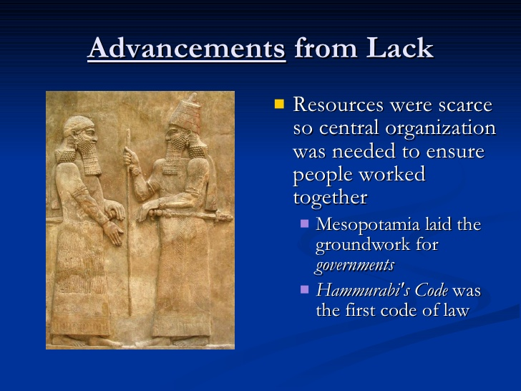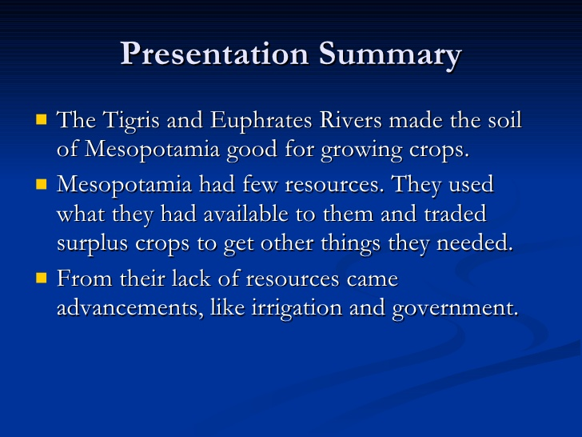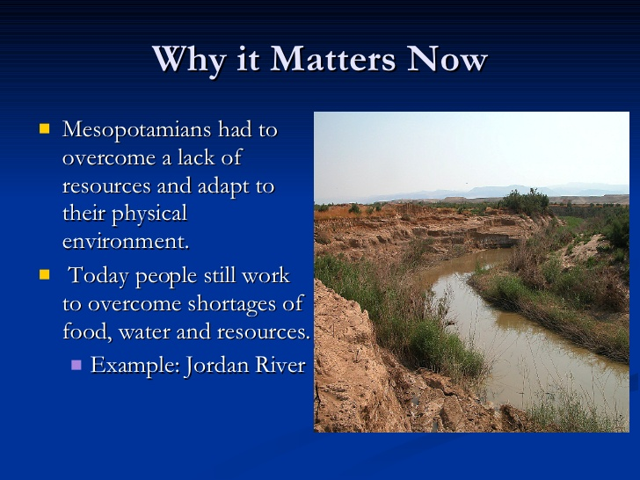 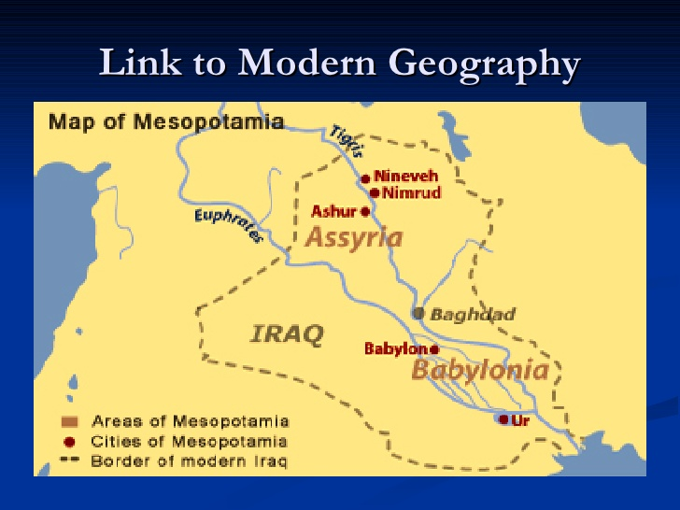Two Column Notes

Topic: | Mesopotamia
Main Ideas | Details

Complete one of the following activities

Challenge A: Come to Mesopotamia!
Background: Mesopotamia was a land with a lot to offer. Its location and natural resources encouraged people to settle there.

Task: Write an advertisement for "The Ancient Times" newspaper that convinces people in other parts of the world to move to ancient Mesopotamia. Tips: · Describe the benefits of the land and its location as well as advancements and inventions of the people who lived there. Explain how these things supported a good lifestyle. · Start with a short catchphrase that will stick in the listener's mind. · Be convincing, but stick to the facts.

OR

Challenge B: People and the Land
Background: Throughout history, the land has shaped the lives of people living on it. Mountains, valleys, rivers, coasts, and climate all affect where and how people live. At the same time, people have changed and used the land for their own needs.

Task: Describe the many different ways that the land was critical to the development of civilization in Mesopotamia. Tips: · You could consider its location, climate, water, and soil, as well as natural barriers that surrounded it. · For each feature you describe, explain how it helped civilizations to grow.

