The Iliad and The Odyssey (Greece)
https://www.youtube.com/watch?v=RbORIBYykuo

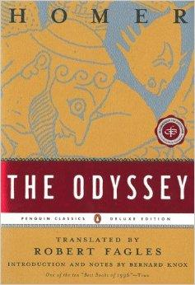
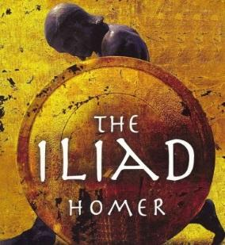
The Iliad and The Odyssey are very long epic poems that are considered two of the best works of literature ever. They both may have been written by an Ancient Greek Poet known only as Homer. The Illiad glorifies war while the Odyssey shows the powers of strength and smarts.
The Iliad is the story of the last year of the Trojan War. This was fought between the City of Troy (Trojans) and the Greeks. The Odyssey is the story of how one of the heroes of the Trojan War, Odysseus, and his adventures on his long journey home from a ten year war. Both epic poems are filled with images and stories that are familiar to modern audiences (The Trojan Horse, Achielles, etc.).
Questions:
- Why do you think stories about war and heroes interest people so much?

- What can a war tell someone about a civilization?
Philosophy (Greece)
https://www.youtube.com/watch?v=bM9lXztV6lc

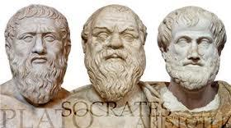
To the left are stone statues of Plato, Socrates, and Aristotle. These are three of the most famous Greek Philosophers.
One of the most unique and wonderful of Greek inventions was philosophy. Philosophy was the special way Greeks attempted to make sense out of the world, in a non-religious way. This means that rather than using myths and stories to understand the world, they would use their intelligence and reasoning skills.
The word “Philosophy” can be broken into two parts: “Philo-” means love, and “-sophia” means wisdom, so the word “philosophy” really means “the love of wisdom.” Basically, philosophy is thinking about the world and making sense out of it.
For example, early Greeks began asking the question, “What exists?” They questioned the world around them and tried to make sense out of what they saw. Other, different philosophies were developed, each of which tried to make sense out of the world.
Eventually, their ideas built upon each other until very complicated philosophies were developed. These early thinkers were so influential that their ideas are still around today, and people still study them in colleges and universities.
Fill in chart with notes while watching video.

