Polytheism in Sumer

Take a look at the map below and answer the questions about Sumer
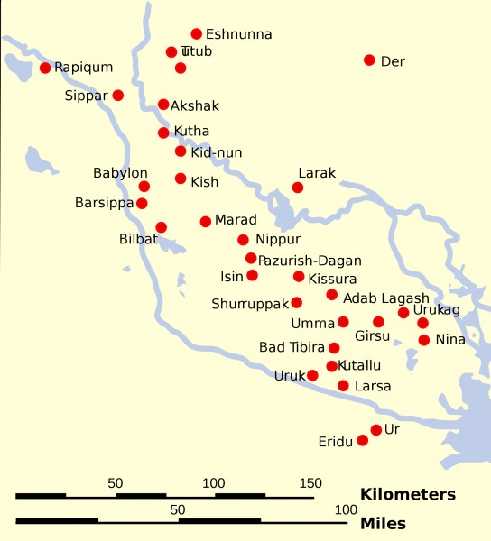

- What is true about the location of almost all of the city-states of Sumer?

- What resources do they have in common?

- How might these common resources have led to conflict?

Religion in Sumer
Resources weren’t the only thing shared by the people of Sumer, they also had a common religion. As you watch the video, complete the chart below.

Things represented by the gods of Sumer | How the people worship daily | How the priests and kings impact daily life | The purpose and uses of the Ziggurat
After watching the video and completing the chart, explain how the people of Sumer were impacted by their religion in the space below:
______________________________________________________________________________________________________________________________________________________________________________________________________________________________________________________________________________________________________________________________________________________________________________________________________________________________________________________________________________________________________________________________________________________________________________________________________________________________________________________________________________________________________________________________

How is the Sumerian’s practice of religion similar to/different from other religions with which you are familiar?

Sumer’s religion is similar to other religions I know by….. | Sumer’s religion is different from other religions I know by….

